Bahria University,

Karachi Campus



LAB EXPERIMENT NO.

**5**

LIST OF TASKS

|  |  |
| --- | --- |
| TASK NO | OBJECTIVE |
| 1 | Print your Personal Data |
| 2 | adding two number using data segment values. |
| 3 | Adding three number using data segment. |
| 4 | Subtract two number. |
| 5 | multiply any two number. |
| 6 | Divide Any two number. |
| 7 | Input 3 number and add Them. |
|  |  |

Submitted On:

Date: 17/11/2021

**Task 1: Print your Personal Data**

**Solution :**

data

name: .asciiz "Juanid SAleem\n"

age: .asciiz "19\n"

mobile: .asciiz "03151181292"

.text

.globl main

main:

Li $v0,4

La $a0,name

syscall

li $v0,4

la $a0,age

syscall

li $v0,4

la $a0,mobile

syscall

Li $v0,10

syscall

**Output :**

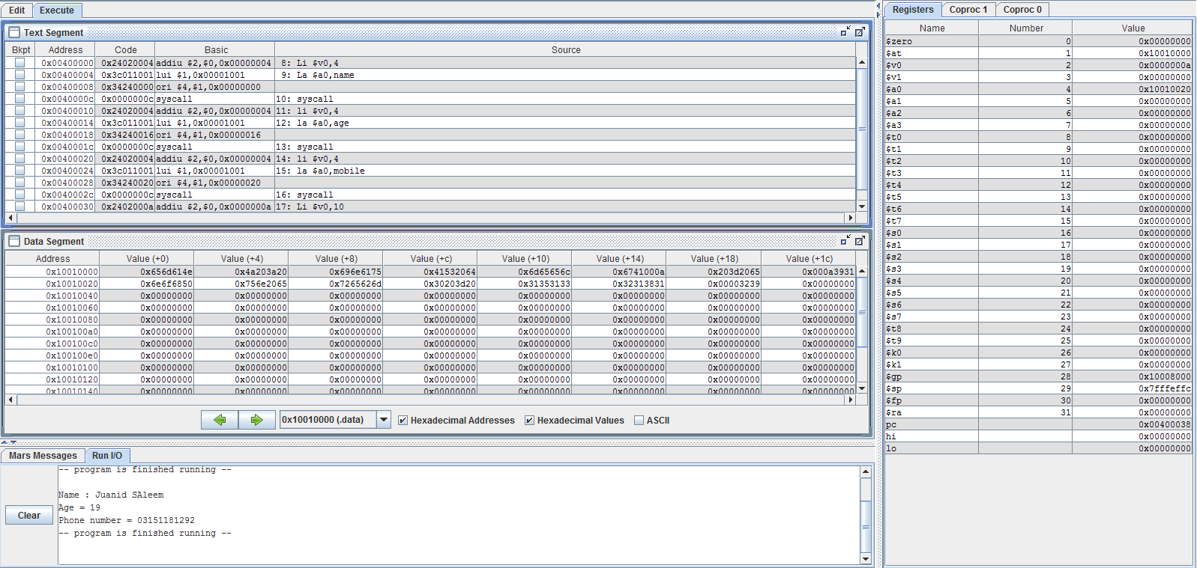

.

**Task 2 : adding two number using data segment values.**

**Solution :**

.data

num1: .word 10

num2: .word 25

.text

.globl main

main:

lw $t0,num1

lw $t1,num2

add $t3,$t0,$t1

li $v0,1

move $a0,$t3

syscall

**Output :**

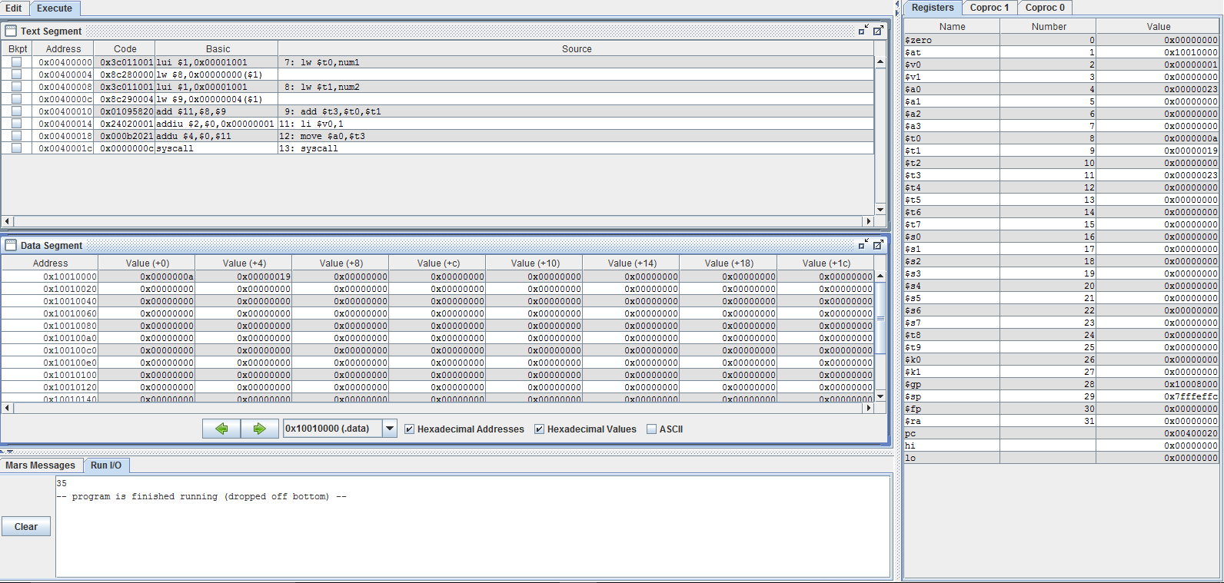

**Task 3 : Adding three number using data segment.**

**Solution :**

.data

num1: .word 10

num2: .word 25

num3: .word 20

.text

.globl main

main:

lw $t0,num1

lw $t1,num2

lw $t2,num3

add $t3,$t0,$t1

add $t4,$t2,$t3

li $v0,1

move $a0,$t4

syscall

**Output :**

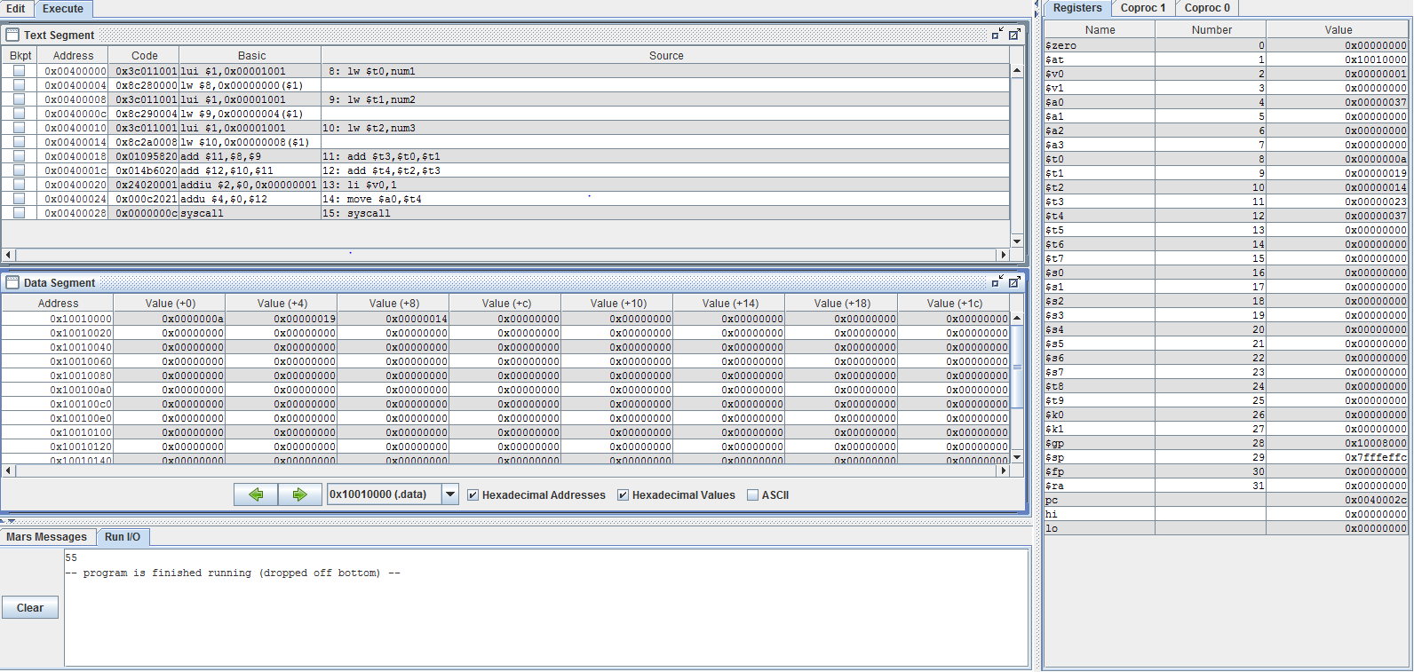

**Task 4 : subtract two number.**

**Solution :**

.data

num1: .word 10

num2: .word 25

.text

.globl main

main:

lw $t0,num1

lw $t1,num2

sub $t3,$t0,$t1

li $v0,1

move $a0,$t3

syscall

**Output :**

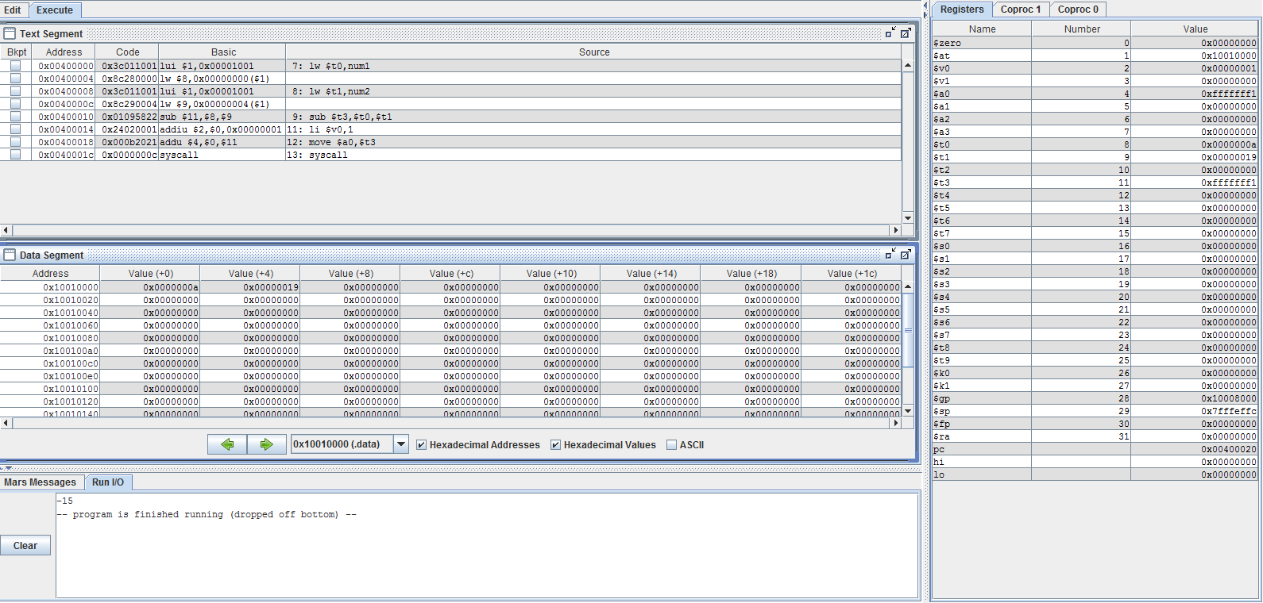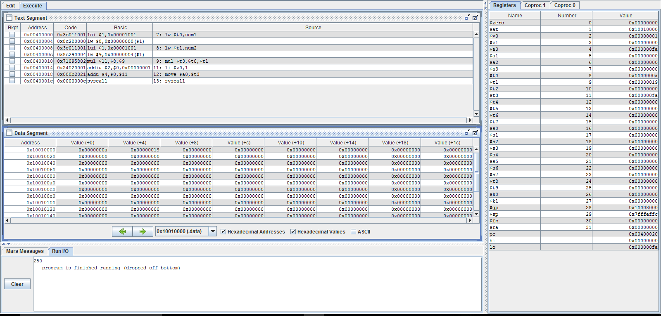

**Task 5 : multiply any two number.**

**Solution :**

.data

num1: .word 10

num2: .word 25

.text

.globl main

main:

lw $t0,num1

lw $t1,num2

mul $t3,$t0,$t1

li $v0,1

move $a0,$t3

syscall

**Output :**

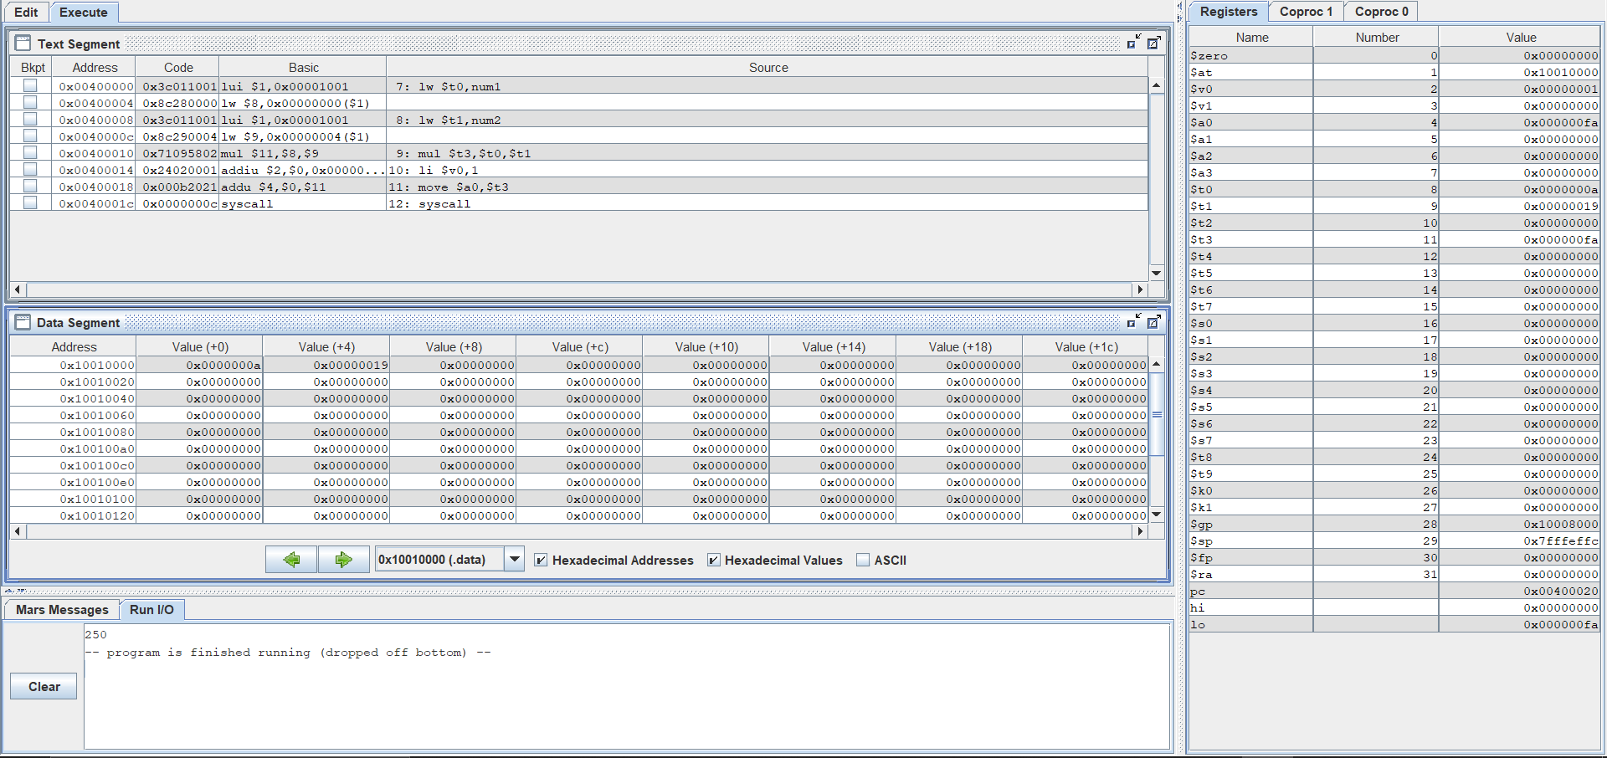

**Task 6 : divide Any two number.**

**Solution :**

.data

num1: .word 10

num2: .word 2

.text

.globl main

main:

lw $t0,num1

lw $t1,num2

div $t3,$t0,$t

li $v0,1

move $a0,$t3

syscall

**Output :**

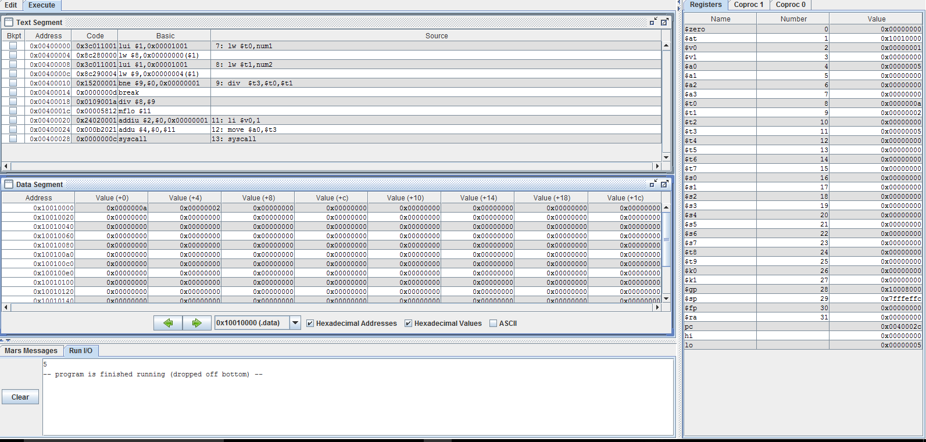

**Task 7 : input 3 number and add Them.**

**Solution :**

.data

prompt: .asciiz "Please enter three numbers: \n"

sum_msg: .asciiz "The sum is: "

.text

.globl main

main:

la $a0,prompt

li $v0,4

syscall

li $v0,5

syscall

move $t0,$v0

li $v0,5

syscall

move $t1,$v0

li $v0,5

syscall

move $t2,$v0

addu $t0,$t0,$t1

addu $t0,$t0,$t2

la $a0,sum_msg

li $v0,4

syscall

move $a0,$t0 # output sum

li $v0,1

syscall

li $v0,10

syscall

**Output :**

